Development Document of Group Authoring

1. **General Explanation**

In the front-end, there are two page files: login.jsp and dashboard.jsp.

Firstly, it shows login.jsp page for user to login and also uses LoginService.java and LogoutService.java to handle this operation. After identify user’s role, it will go to dashboard.jsp.

Main javascript functions are in js/group.dashboard.js.

1. **DB description**

This application connects to three databases: aggregate, portal_test2 and um2. The um2 database stores basic user modals. Portal_test2 stores more detail information of user and other data. Aggregate database stores information mainly for this application, such as courses or groups.

Every time the application updates data, it should be considered to update all of these three databases.

1. **Back-end files explanation**

There are five packages in back-end: security, beans, dbpersistors, ajaxpersistors and um.

1. Classes in security are used to check user’s role when the user is logging in to system. It uses table ent_user and rel_user_user in Portal_test2 database to check user’s role.
2. Package beans contains Userbean and Notification’s bean. One is for all information of one user, the other is for the notification sent from back-end to front-end.
3. Ajaxpersistors package has all back-end service for request sent from ajax from front-end. Classes in this package can Get/Add/Remove/Update data of group or user. It gets request from front-end and uses classes in dbpersistors package to change data in three databases.
4. Package dbpersistors opens connections to three databases and gives functions for other package to use. All pre-statements are written in DbPersistors.java.
5. **Installation**
6. Import three databases: aggregate, portal_test2, um2 to database.
7. Set up connections for database. Change content in WebContent/META-INF/context.xml. Change url, username, password for your configuration. 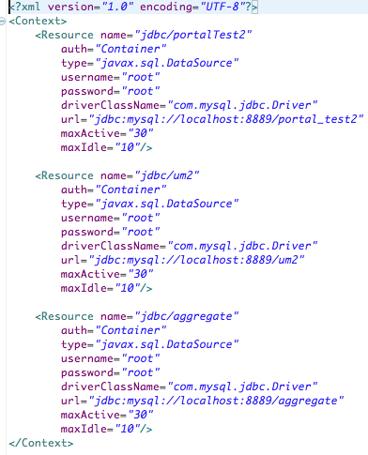
8. This application uses one library for json operation. So you must change the path for this library(org.json.jar). 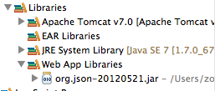
9. If you do not know one user name and password, you cannot login to dashboard.jsp. One way for you to quickly get into dashboard is to change LoginService.java in security package. You can change function checkPasswordMD5 as following picture. Then you can just use any user name in database and type whatever password you want to login to system.

